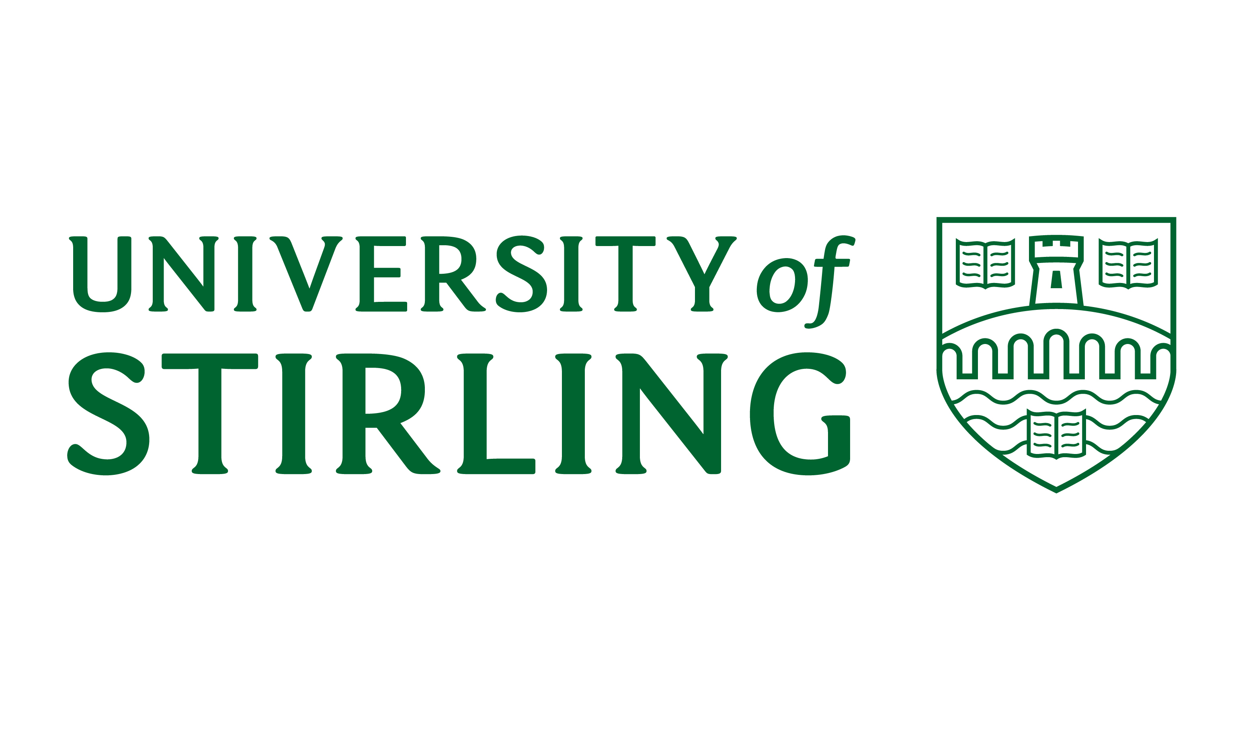
Donation Form 
Name: Phone Number:
Address: Preferred Email Address:
Year of University of Stirling Graduation (if applicable):
City: Degree subject (if applicable):
Postcode/Zip Code: Reference (office use only): 2019/DFA/KB/ER

Making a single gift you can also donate on line at: www.stir.ac.uk/carddonate
I would like to make a single gift of: £1000 £500 £100 Other: £ _______
Please debit my: Visa MasterCard UK Maestro Eurocard

Card Number: Expiry Date:

Start Date (if applic) Issue No: Security Code:

Name on Card: ______________________________________Signature:

Date:
D
M
M
Y
Y
D

I enclose a cheque made payable to University of Stirling I enclose a Charities Aid Foundation (CAF) voucher

I transfer via BACS to the University of Stirling. [Sort Code: 20-33-70] [Account No: 50703745] with reference DFA

Making a regular gift you can also donate on line at: www.stir.ac.uk/debitdonate INSTRUCTIONS TO YOUR BANK OR BUILDING SOCIETY TO PAY BY DIRECT DEBIT
I would like to make a regular gift of £ __________ each month/quarter/year starting on 4th/15th of _____________2019
Bank/Building Society name
Name(s) of Account Holder(s)
Bank Sort Code: Account No:

Signature(s) ___________________________________________________________________________________________________________

Service User Number: 900671
Instructions to your Bank or Building Society: Please pay the University of Stirling from the account detailed in this Instruction subject to the safeguards assured by the Direct Debit Guarantee. I understand that this Instruction may remain with the University of Stirling and if so, details will be passed electronically to my Bank/Building Society.



Please claim Gift Aid on my donation and any donations I make in the future or have made in the past 4 years to the University of Stirling. I understand that this will allow the University to claim an additional 25% of my donation(s) value from HMRC. I declare that I pay annual income and/or capital gains taxes up to the value of my charitable donations. While donating, I will inform the University if this ceases to be the case, if I wish to cancel my declaration, or if I change my address.
D
D
M
M
Y
Y
Signature Date:

Other Gifts Anonymous Gifts
Please send me information about leaving a gift in my Will. I don’t want my gift amount disclosed
I have already included a gift to the University in my Will. I don’t want my name on a list of supporters
My company will match my gift. The appropriate form is included

